CPU Scheduling

- CPU–I/O Burst Cycle – Process execution consists of a cycle of CPU execution and I/O wait

Alternating Sequence of CPU And I/O Bursts

CPU Scheduler
- Selects from among the processes in memory that are ready to execute, and allocates the CPU to one of them
- CPU scheduling decisions may take place when a process:
  - Switches from running to waiting state
  - Switches from running to ready state
  - Switches from waiting to ready
  - Terminates
- Scheduling under 1 and 4 is nonpreemptive
- All other scheduling is preemptive
Dispatcher
- Dispatcher module gives control of the CPU to the process selected by the short-term scheduler; this involves:
  - switching context
  - switching to user mode
  - jumping to the proper location in the user program to restart that program
- Dispatch latency – time it takes for the dispatcher to stop one process and start another running

Scheduling Criteria

- CPU utilization – keep the CPU as busy as possible
- Throughput – # of processes that complete their execution per time unit
- Turnaround time – amount of time to execute a particular process
- Waiting time – amount of time a process has been waiting in the ready queue

- Response time – amount of time it takes from when a request was submitted until the first response is produced, not output (for time-sharing environment)
- Max CPU utilization
- Max throughput
- Min turnaround time
- Min waiting time
- Min response time

CPU scheduling Algorithms:
First Come First Serve(FCFS) Scheduling
- Jobs are executed on first come, first serve basis.
- Easy to understand and implement.
- Poor in performance as average wait time is high.
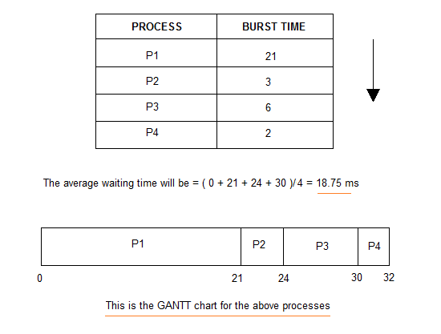
Shortest-job-first(sjf) scheduling:
- Best approach to minimize waiting time.
- Actual time taken by the process is already known to processor.
- Impossible to implement.
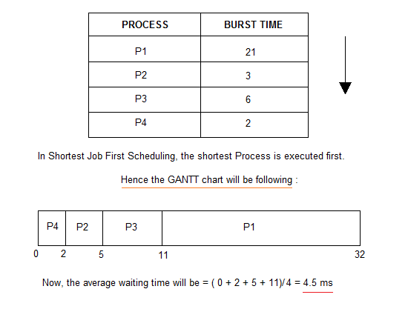
In Preemptive Shortest Job First Scheduling, jobs are put into ready queue as they arrive, but as a process with short burst time arrives, the existing process is preemptied.
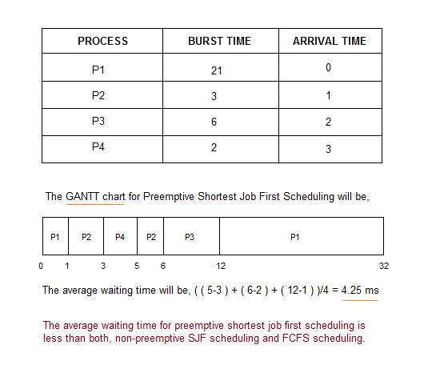
Priority Scheduling
- A priority number (integer) is associated with each process
- The CPU is allocated to the process with the highest priority (smallest integer º highest priority)
- SJF is a priority scheduling where priority is the predicted next CPU burst time
- Problem
  - º Starvation – low priority processes may never execute
- Solution
  - º Aging – as time progresses increase the priority of the process

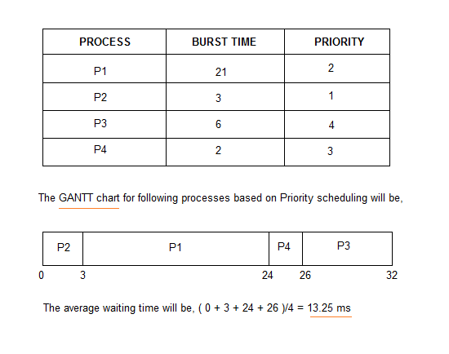

Round Robin (RR)
- Each process gets a small unit of CPU time (time quantum), usually 10-100 milliseconds. After this time has elapsed, the process is preempted and added to the end of the ready queue.
- If there are n processes in the ready queue and the time quantum is q, then each process gets 1/n of the CPU time in chunks of at most q time units at once. No process waits more than (n-1)qtime units.
- Performance
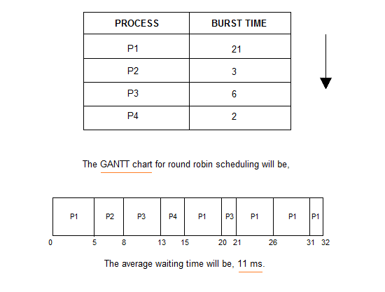
Multilevel Queue CPU Scheduling

- Ready queue is partitioned into separate queues: foreground (interactive) background (batch)
- Each queue has its own scheduling algorithm
  - foreground – RR
  - background – FCFS
- Scheduling must be done between the queues
- Fixed priority scheduling; (i.e., serve all from foreground then from background). Possibility of starvation.
- Time slice – each queue gets a certain amount of CPU time which it can schedule amongst its processes; i.e., 80% to foreground in RR
- 20% to background in FCFS
Multilevel Feedback Queue
- A process can move between the various queues; aging can be implemented this way
- Multilevel-feedback-queue scheduler defined by the following parameters:
  - number of queues
  - scheduling algorithms for each queue
  - method used to determine when to upgrade a process
  - method used to determine when to demote a process
  - method used to determine which queue a process will enter when that process needs service
Example of Multilevel Feedback Queue
Three queues:
Q0 – RR with time quantum 8 milliseconds
Q1 – RR time quantum 16 milliseconds
Q2 – FCFS
Scheduling
- A new job enters queue Q0 which is served FCFS. When it gains CPU, job receives 8 milliseconds. If it does not finish in 8 milliseconds, job is moved to queue Q1.
- At Q1 job is again served FCFS and receives 16 additional milliseconds. If it still does not complete, it is preempted and moved to queue Q2.
Multilevel Feedback Queues

Algorithm Evaluation
- Deterministic modeling – takes a particular predetermined workload and defines the performance of each algorithm for that workload
- Queuing models:
  - The computer system is described as a network of servers.
  - Each server has a queue of waiting processes.
  - The CPU is a server with its ready queue, as is the I/O system with its device queues.
  - Knowing arrival rates and service rates,
  - we can compute utilization, average queue length, average wait time, and so on.
  - This area of study is called queueing-network analysis.

- Simulations:
- Implementation

Evaluation of CPU schedulers by Simulation

